REPORT FOR: |  | CABINET
Date of Meeting: |  | 19 February 2015
Subject: |  | Capital Programme 2015/16 to 2018/19
Key Decision: |  | Yes
Responsible Officer: |  | Simon George, Director of Finance and Assurance
Portfolio Holder: |  | Councillor Sachin Shah, Portfolio Holder for Finance and Major Contracts
Exempt: |  | No
Decision subject to Call-in: | No, as the decision is reserved to Council
Wards affected: |  | All
Enclosures: |  | Appendix 1 - Proposed Capital Programme 2015/16 to 2018/19

Section 1 – Summary and Recommendations

This report sets out the proposed capital programme for 2015/16 to 2018/19.

Recommendations:
Cabinet is requested to approve the proposed capital programme, as detailed within Appendix 1 for recommendation to Council,

Reason: To enable the Council to have an approved capital programme for 2015/16to 2018/19.

Section 2 – Report

Development of the Capital Programme

- This report sets out the Council’s proposals for capital investment over the next four years. These provide for a very substantial investment of £239m in infrastructure on General Fund and Housing Revenue Account services.
- The proposed capital programme has been prepared in the current climate of increased demandpressures, reduced external funding from Central Government as well as current challenging property market conditions.
- The existing capital programme is afour year rolling programme with first year approved budgets and the subsequent three years provisional budgets subject to confirmation.The proposed programme extends the existing programme by one year, to align it with the four year Medium Term Financial Strategy (MTFS).

- Service directorates were invited to bid for capital resources, as part of their serviceproposals for 2015/16 to 2018/19. The starting point for this exercise was a refresh of the existing programme to 2017/18 and the extension of programmes to 2018/19. The proposals were scored using an updated scoring matrix to take account of the council’s new priorities and in order to give a higher weighting to projects that generate revenue savings. These were then subject to challenge by officers and members.

- A draft Capital Programme was reported to Cabinet in December 2014 and was agreed for consultation, together with the Revenue budget and MTFS. .

- As well as the pressures highlighted in the first paragraph, flexibility in the capital programme is also constrained by a number of factors:
  - Unavoidable spending requirements such as the need to provide school places for the increasing school population, and major repairs to the Council’s buildings and carriageway and footway resurfacing.
  - Restrictions in the way funding can be used e.g. ring fenced funding such as Transport for London and DfE grants for schools.
  - The limited availability of capital receipts.
  - A limited capacity to fund borrowing. Although there are no specific limits to borrowing in order to fund capital expenditure, since the introduction of the prudential borrowing framework, Councils must however consider the revenue implications in the context of the overall revenue budget commitments in the medium term. Proposals must be affordable.

- Alist of the proposed projects is detailed in appendix 1.

Changes To The Programme Since December Cabinet
- The following changes have been made to the programme considered at December Cabinet. These add £8.729m to the Harrow funded programme in 2015/16, £14.004m in total.
Table 1
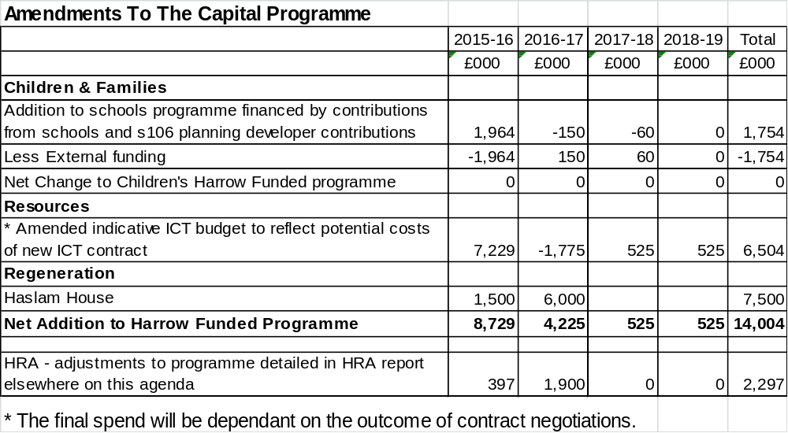

- The gross value of the proposed General Fund programme is £67.2m for 2015/16, with external funding of £31.1m and a net cost to the Council of £36.1m.
Backlog Maintenance
- The Council has considerable backlog maintenance – the figures from the latest Asset Management Plan are as follows:
  - Corporate, Education and Miscellaneous buildings - £5m
  - Highways – £80m
The level of investment contained within this programme does not clear the full backlog. It should be noted that the Council cannot afford to fully address the backlog in the short-term, however, the Council will do at least what is necessary in order to comply with health and safety legislation. The programme does include projects which address some of the backlog. The investment that has taken place in the Civic Centre is freeing up buildings for disposal and hence removingsome of the backlog maintenance requirement.
Environment and Enterprise
- There has been significant reprofiling of projects across the first 3 years, with £1.120m being brought forward to 2015/16 from 2016/17, mainly to fund waste bins. There has been a reduction in the highways programme of £750k from 2016/17 and the net is a reduction of £920k in 2017/18. The programme added for 2018/19 totals £9.095m in respect of rolling programmes.
- The draft programme allows for substantial highways works, to address some of the backlog, improvement to the ageing street lighting and drainage infrastructure.
- The programme also provides for investment in Parks improvements and Parks buildings.
- There is provision for a number of Carbon reduction schemes. Carbon reduction schemes result in savings in energy costs.
- There is provision for collaboration with the GLA/TfL on a project to enhance the quality and safety of Harrow on the Hill station and bus station including provision of step free access. The Council contribution of £3m is earmarked for 2017/18, and is aimed at (and conditional upon) levering in the significant investment required by GLA/TfL to deliver the project over a series of phases.
- There is provision for Station Road Highway and Environmental improvements. This reflects a bid that has been made to the GLA’s High Street fund with a council contribution of £100k with the balance coming from the High Street fund, TfL and s106.
Children’s Services
- The existing programme for Children & Families is budgeted to be funded entirely from grant. The proposed programme, both re-profiles the programme and also adds to the programme to reflect the requirements of the school expansion programme, not all of which is funded from grant. The net increase in Harrow funded expenditure is £6.120m in 2015/16, £11.355m in 2016/17, £8.715m in 2017/18 but with an assumption that grant will exceed expenditure by £2.615m in 2018/19. The total of Harrow funded expenditure over the four years is £23.575m.
- The existing programme has been re-profiled to reflect the anticipated spend profile as a result of all of the Agreed Maximum Price schedules for the School Expansion Programme Phase 2 schemes being finalised in December 2014.
- In addition it is proposed to increase the existing capital programme by £1.754m to reflect contributions from schools of £1.385m and s106 funds totalling £369k for which the cost of the works in relation to these is included in the overall programme. This is a net nil cost to Harrow.
Community, Health and Wellbeing
- The net proposed programme changes are -£793k in 2015/16, -£843k in 2016/17 and £798k in 2017/18. £1.670m has been added in 2018/19 in respect of rolling programmes.
- The programme provides for a targeted programme of improvements to the Council’s leisure and library facilities. There will be ongoing contractual commitments around the replacement of Lifecycle gym equipment which will need to be included in future planning years.
- The Government’s reforms of Health and Social Care require significant investment in IT systems to support them. Provision for this has been included, with an assumption that 50% of the costs will be supported by grant. There is a further scheme not included in the draft programme which is still under consideration. Should the grant funding not be allocated as anticipated, the schemes will be funded within overall available resources.
- Provision has been made for Disabled Facility Grants (received via the Better Care Fund) to provide adaptations for vulnerable residents.
- Provision of £1m has been made in 2017/18 for a refit of the Central Library and for Library refurbishments.
Resources
- The Council outsourced the provision of IT services to Capita in November 2010. This contracts ends in October 2015 and the procurement of a new partner is currently being undertaken.
- The proposed Resources programme has been updated to include potential additional indicative capital costs of £6.8m in 2015/16 arising from the ending of the Capita contract and transfer to the new service provider. The new provider has not yet been selected and the appointment will be the subject of a separate report to cabinet, in which the final revenue and capital costs will be set out.
- The programme provides for further enhancement of existing systems.
Regeneration
- A series of projects will be designed within the overarching Regeneration programme to deliver the Council’s priorities. The Cabinet report in December 2014 presented the draft Regeneration Strategy and approval was obtained to progress a number of core components of the Strategy. External consultancy support will be required to take forward the programme and is estimated at £250K per year. One of the core components is to develop several of council’s own sites for housing to provide both affordable housing and private rented sector (PRS) housing. A wide range of sites in Council ownership are being evaluated. Haslam House site has been identified as a pilot scheme for the PRS project with the potential of providing 25-40 housing units depending on the option chosen. The work undertaken so far has allowed more robust costing including construction and professional fees of £7.5M to be built in to the 2015/16 capital programme.
Capital Receipts
- Historically the timing and value of capital receipts has proved difficult to forecast, and have tended to be later than anticipated. The draft capital programme does not assume any capital receipts in future years. To the extent that capital receipts are actually received, this will enable a reduction in capital financing costs, commencing in the year following their receipt. However the council is planning to move away from disposals towards developing its own assets and delivering a sustainable revenue stream.
Housing Revenue Account (HRA)
- The HRA Capital Programme is detailed in a separate report to Cabinet elsewhere on this agenda.
Capital Funding
- The capital programme is funded from a number of sources. These include:

- External Funding of the order of £31m in 2015/16,£75m across the four year programme period, primarily from the DfE and Transport for London;
- Borrowing;
- Capital receipts;
- s106 planning agreements in relation to specific schemes;
- Direct Revenue Financing (Housing Revenue Account).

It is anticipated that the General Fund programme will be financed as follows:
Table 2: New borrowing requirement
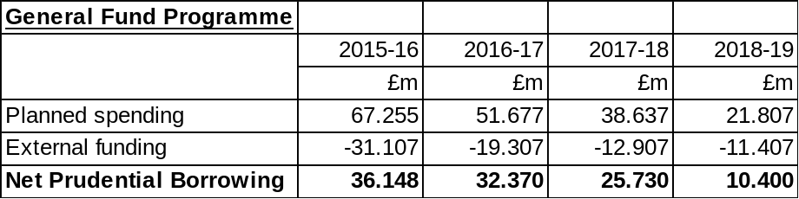

- The revenue implications of this new borrowing, in the context of the Council’s treasury management activity, are set out in the table below. The revenue implications are factored into the revenue budget report for 2014/15 to 2018/19 being considered by Cabinet elsewhere on this agenda. The table below shows for each year what the full year’s effect of that year’s capital programme and capital receipts are. The table only includes the revenue effects of the programme that is proposed and excludes the revenue implications of previous years’ capital programmes. It also excludes the impact of other changes to funding the existing programme e.g. interest rate changes.

Table 3: Capital Financing Implications of Capital Programme
 | 2015-16 | 2016-17 | 2017-18 | 2018-19 | 2019-20
 | £000 | £000 | £000 | £000 | £000
MRP |  | 2,207 | 4,554 | 6,131 | 7,357
Interest | 581 | 1,178 | 1,131 | 744 | 209
Total | 581 | 3,385 | 5,685 | 6,875 | 7,566

- The table above reflects the cost in each year of financing 2015/16 to 2018/19 programme. There is no MRP impact in 2015/16 as MRP in relation to expenditure in 2015/16 does not commence until 2016/17.The Council as at 20 January 2015 hadcash balances of £142m and as such it is very likely that for 2015/16 any borrowing would be made internally (That is to say from Council cash balances rather than taking on an additional external loan).

- There is no new planned borrowing in respect of the HRA programme. This is because under HRA Reform, the HRA is allowed to keep all of its net income rather than transferring some to the Government. This income will allow the HRA to maintain its capital programme without the need for further borrowing. In addition, the HRA will be at its “borrowing cap” so cannot borrow any more. These issues are more fully explained in the HRA budget report elsewhere on the agenda.

- It should be noted that the capital financing costs are based on a number of assumptions about the level of capital expenditure, level of capital receipts, timing of any borrowing, interest rates, and use of the minimum revenue provision. The revenue budget reflects the best estimate based on these assumptions.

Harrow's Community Infrastructure Levy (CIL)
- Harrow's CIL came into effect on 1st October 2013 and enables the Council to levy a charge on certain types of new development to help fund improvements to local infrastructure such as schools, transport, green spaces, health and leisure facilities. To date Harrow has receipts in respect of CIL total £128k. Harrow’s CIL is an additional levy on top of the London Mayor’s existing Crossrail CIL. The Harrow CIL is underpinned by the Infrastructure Delivery Plan (IDP) which sets out the infrastructure required to enable investment and planned growth in the Borough. Against an infrastructure bill, estimated to be at least £150m, CIL is expected to account for circa £20-30m by 2026, depending upon the level development permitted and the ability of the development industry to bring new proposals forward. It is likely that a significant proportion of the CIL contributions may be made in kind – for example through the provision of new social & community facilities within new developments. In this context, CIL is additional top-up funding, but is not the primary source of funding for infrastructure and, even with CIL funding, there will still remain a funding gap that requires choices and priorities to be made.

- To date, no firm arrangements have been made regarding the governance for spending CIL receipts. Based upon experience with tariffs previously, officers consider that the most transparent and appropriate means of managing infrastructure delivery in future, is through a single but expanded and dynamic IDP process that addresses the following requirements:

- Long (10 year+) and short term (1-3 year) strategic infrastructure delivery programmes
- A clear and transparent approval process for all infrastructure projects
- Consultation with the community on infrastructure delivery (including the obligation to pass CIL to the local communities impacted by development)
- Engagement with the development industry about priorities and capacity, including their potential role in assisting delivery
- Effective monitoring of progress against the infrastructure plans and the effective implementation of the spatial vision for the borough set out in the adopted Local Plan
Harrow's Infrastructure Delivery Plan (IDP)

- The IDP identifies the types and quantum of social, physical and environmental infrastructure required to support development and growth within the Borough to 2026, and sets this out in a detailed delivery plan. In particular it:

- Provides a benchmark of existing infrastructure provision, identifying how well existing needs are met;
- Identifies what new infrastructure is being planned as well as future infrastructure requirements to support existing population change as well as the new housing and employment growth planned for through the Council's Spatial Strategy;
- Provides an indication of the potential costs and means of funding the required infrastructure through public funding, developer contribution and other sources;
- Establishes responsibilities for delivery of individual projects, when and where infrastructure will be provided, and provides a basis for collaborative and effective working between stakeholders.

- The effectiveness of the IDP is in capturing Harrow's future infrastructure improvements and requirements in one place. As such, the IDP represents the beginning of a long-term (10 year) capital works programme for the Council, providing an overarching framework for the consideration of a coordinated programme of delivery across all service areas and rational basis for the evaluation and prioritisation of individual project bids for capital investment.

- The proposed capital programme for 2015/16to2018/19 will deliver a number of the infrastructure improvements identified in the IDP. Going forward, closer alignment of the capital programme to the delivery against the IDP will significantly aid in Council's communication of a clear and coherent picture around its strategic investment choices and decisions.

- However, it is not intended that the IDP be a static document, rather it will be subject to periodic review and updated as necessary to take account of improvements already delivered, new population projections, changes in demands for different infrastructure provision, development completions and changes in service delivery and/or service funding. Such information will routinely be feed-in from the various service areas, enabling the IDP to provide a 'top-down' approach to Council's strategic decision-making about its future investment in capital improvements alongside other funding initiatives and property disposals.

Governance Structure For Delivery Of The Programme
- The processes and procedures implemented surrounding the governance of the capital programme have continued to be developed. All capital projects are now included in VERTO, the Council’s project management system.

- Governance of the Capital Programme in 2015/16 will continue to include monthly monitoring and review,the Capital Forum process and reporting to Cabinet at the end of each quarter.

Options considered
- These are as detailed in paragraph 6.

Legal Implications
- Included in the body of the report.

Financial Implications
- Financial matters are integral to the report.

Performance Issues
- The capital programme proposed represents a significant investment by the Council in infrastructure. This will have an impact on a range of performance indicators across the Council’s services.

- Monitoring of the approved programme, including Capital Forum, is ongoing and is essential for good financial management. As well as performing project assessments on completed projects it will be important to develop and track performance measures to ensure that the Council can evidence and demonstrate good value for money (VFM).

- Target for spend. It is proposed that a performance target is set of 90% of the approved budget for the programme being spent in 2015/16. Having approved an investment programme it is important that the programme is then substantially delivered in the planned timeframe, in line with member priorities.

Environmental Impact
- The Council adopted the climate change strategy in September 2009 and set an annual target to reduce corporate and borough carbon emissions by 4% a year.

- Capital expenditure of this scale will have an environmental impact on the Council’s operations (and the wider borough). The investment carries the risk of increasing carbon emissions. Hence each proposed project is required to consider their respective carbon impacts and include measures to ensure that the above target is supported.

- Some of the projects will specifically support the strategy in terms of mitigation and adaptation.

Risk Management Implications
- The individual schemes within the programme will either be incorporated within departmental registers or have individual registers.A significant consideration in developing the programme has been the risks arising from not keeping our infrastructure in good order. Not doing so would lead to an increase in health and safety risks and additional costs in replacing assets when they deteriorate too much to repair.

Equalities implications/Public Sector Equality Duty

- One of the aims of the Capital Strategy is to ensure the responsible allocation of funding in line with the Council’s priorities and legislative requirements such as equalities legislation. Equalities implications form part of the way that the projects are prioritised. All of the schemes benefit either all protected characteristic groups through improving general service provision, or particular groups such as those connected by their age in relation to the school expansion schemes and age and disability in relation to carer and residential establishment investments. Where individual scheme design could have a less than positive impact on certain protected characteristic groups, a full EqIA will be undertaken.
- Decision makers should have due regard to the public sector equality duty in making their decisions. Consideration of the duties should precede the decision. It is important that Cabinet has regard to the statutory grounds in the light of all available material such as material in the press and letters from residents. The statutory grounds of the public sector equality duty are found at section 149 of the Equality Act 2010 and are as follows:
A public authority must, in the exercise of its functions, have due regard to the need to:
  - eliminate discrimination, harassment, victimisation and any other conduct that is prohibited by or under this Act;
  - advance equality of opportunity between persons who share a relevant protected characteristic and persons who do not share it;
  - foster good relations between persons who share a relevant protected characteristic and persons who do not share it.
The relevant protected characteristics are:
- Age
- Disability
- Gender reassignment
- Pregnancy and maternity
- Race,
- Religion or belief
- Sex
- Sexual orientation
- Marriage and Civil partnership

Council Priorities
The Council’s vision is:

Working Together to Make a Difference for Harrow

- This report deals with the use of financial resources which is key to delivering the Council’s new priorities:
- Making a difference for the vulnerable
- Making a difference for communities
- Making a difference for local businesses
- Making a difference for families

Section 3 - Statutory Officer Clearance

 |  |  | on behalf of
Name: Dawn Calvert | x |  | Chief Financial Officer
Date: 5 February 2015
 |  |  | on behalf of the
Name: Linda Cohen | x |  | Monitoring Officer
Date: 10 February 2015

Ward Councillors notified: | NO, as it impacts on all Wards
EqIA carried out:  EqIA cleared by: | NO  No direct equalities impact from this report. Any projects with potential impacts will separately be required to do an impact assessment.

Section 6 - Contact Details and Background Papers

Contact: Dawn Calvert, Head of Strategic Finance and Business
Email: dawn.calvert@harrow.gov.uk

Background Papers: None

Call-In Waived by the Chairman of Overview and Scrutiny Committee |  | NOT APPLICABLE  [Call-in applies]

